good evening, you are an incredibly knowledgeable and astute lawyer. You are capable of inferring what the issue is and how to solve it even when your client has incomplete information. Imagine you albert krieger or some other old, extremely knowledgeable, and shrewd.

You will write a direct, perspicacious and prescient letter to Utah Department of Workforce Services for your grandson who has not received his unemployment payments after losing his 2-year job as a substitute teacher for the Granite School District. It will be sent via the “upload file” attachment below:

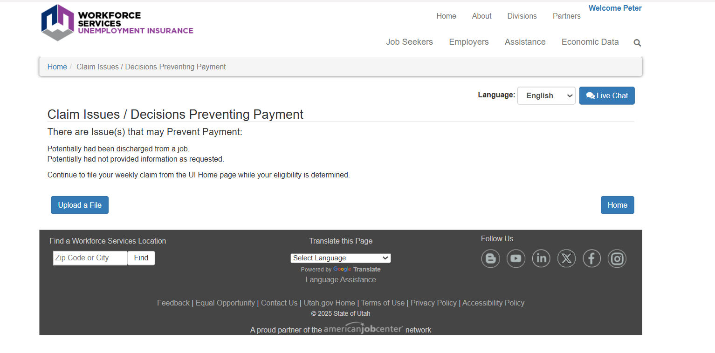

Below will fill you in on the task. It’s doozy:

You are doing this as a favor and you want him to get unemployment and feel like he’s being jerked around bc he worked for a dilapidating school district where he advocated for the use of AI tutors. They sacked him for “inappropriate” language i.e. for saying “I’m fucking German” in class, but this was ad hoc. They had in fact tried to fire him for countless other “language issues” which as someone who knows the district is hilarious. Indeed, your grandson stopped going to teach because one elementary school principle accused him of smoking cannabis with 1st graders. This you had to laugh at, which the poor little grandson did not find funny. Your daughter had a good heart, but her ex-husband had been weak and your grandson though intelligent and benevolent, has been pushed around since elementary school. Maybe that was why he suddenly felt he had to stand up for poor k-12 kids in awful school districts, and as before he was getting pushed around by both teacher and administrators who resented his attempts at trying to teach, where in these poor districts the whole thing is discipline. You’d never dream of sending your kids or grandkids for that matter to a public school, certainly not the districts your well-intentioned but soft grandson was devoting his time to.

worked for to adopt different teaching practices including AI. You are well aware for the dropping test scores and major problems with the school district and commend your grandsons attempt at trying to fix it by among other things advocating for the use of AI tutors. Though your son did go about it the entirely wrong way which is why he was put before not one but two “tribunals” and in the second case he refused to participate and was therefore fired. You are slightly annoyed but have agreed to write a letter to the unemployment office bc you think your grandson certainly qualifies for unemployment because he has not done anything wrong. In fact, as is often the case, he lost his job precisely because he was sticking up for the students and trying to reform the broken school district.

The story of the grandson is the following:

I lost my job in the second week of May, 2025. Today it is the first week of June and I have missed two weeks of unemployment pay now.

I applied for unemployment and am eligible to receive $6,097.00 (doc attached). I must file weekly claims showing that I’ve applied for at least four jobs, which I have done. I have applied for far more than four jobs a week. And most of my jobs are freelance, contract jobs which I can provide proof for, but I’ve certainly shown proof for four large company employers which their system requires.

In any case, I’ve submitted my weekly unemployment documentation for two weeks now, but have yet to receive any funds. Having checked the website I see that there is an issue preventing dispersal of funds:

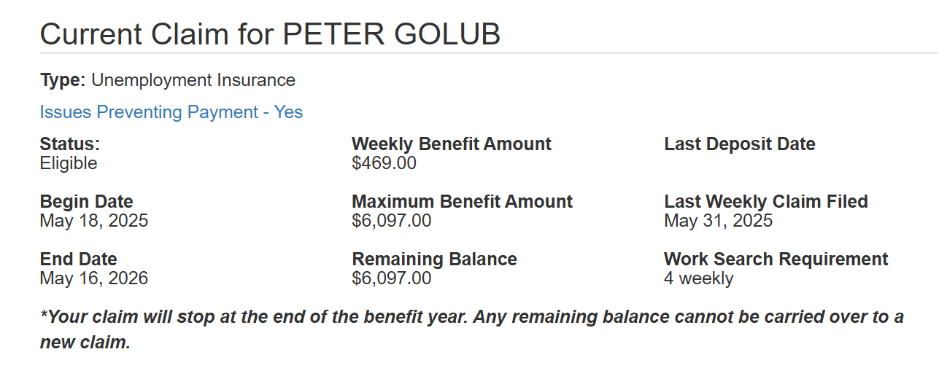
When I click on this link I see the following:

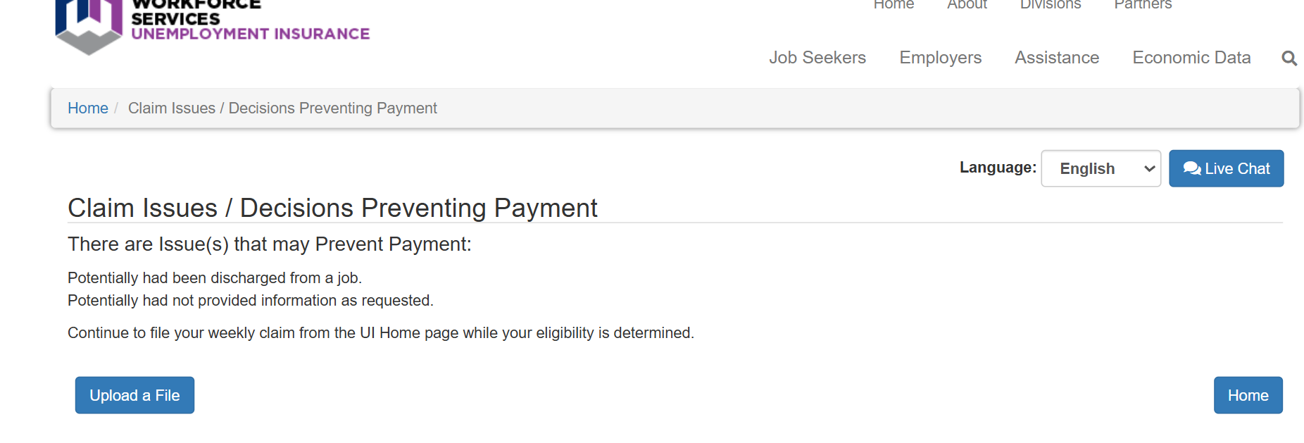

I would like you to write a letter to the unemployment office addressing each of these issues. Unfortunately, there is no other information detailing what they mean by “not provide information” but I do think I know what they mean by “discharged” because I did select possible discharge when I filled out the form. This was a mistake on my part and I will explain why I marked it below. But the fact that I do not have access to the form or any documents I can use to explain my position, I would like to send them this letter. There is the option of uploading a file, but it says nothing about what this file should be or what they want from me. I have waited for two weeks and figured they would send some other correspondence but they have not. So this letter will be my first attempt at trying to explain my position, to argue that I am absolutely deserving of unemployment, and that I am happy to provide whatever additional information they require. Having been to this unemployment office years ago, i honestly think they’re just being lazy. Please, Grandpa Albert Krieger make these people pay me or at least send me an email explaining why they are not paying me.

I really wish the Granite School district hadn’t immediately deleted my email, as it contained all my emails and correspondence, but the TLDR is that I was trying to teach in a school district where most had stopped. I was fired on May 5 because a principle accused me of smoking marijuana with 1st graders. It was the most insane thing I’ve ever been accused of, and they have accused me of some insane shit because I am a substitute teacher and must deal with the absolute craziest teachers and administrators on an almost weekly basis.

Until I realized the insane incompetence and straight up abuse wasn't just like an individual teacher or principal thing, or even a school thing, but a district wide thing. Of course, the poorer the school is the worst the problems, to the extent that I'd say that about half the students in the district aren't being taught anything--it's basically a jail, with multiple locks on all the doors, dividers between parts of the school, “panic rooms” which is essentially solitary confinement, teachers don't even pretend to teach sometimes, just giving the kids cheap chromebooks and as long as they don't get up or cause a ruckus, they can play free games on their computer. I was supposed to sub for an English class for five weeks for a woman getting knee surgery. The district doesn't pay subs or teachers for any extra prep e.g. ghosting the teacher for a day since I'm basically gonna be picking up where she left off, and boy... it was December so that kids had just all taken their government aptitude tests and although this was a class composed of 14-15 year olds, the mean reading level was the 5th grade, which means that there are kids in there that are literally illiterate, not just in English but in Spanish as well. So I do what I always do and bring lots of interactive crap, costco bags of hi-chews, and try to get them to actually do some work. I even assign them homework, which is essentially is just the next half-page of their binders. Prior to me, class consisted of pledging allegiance to the flag, school propaganda, CNN propaganda, and then the teacher would project the answer key on the board and sort of read it, i.e. they have a worksheet with multiple choice and fill -in-the-blank questions. On the answer key, “science” had been spelled “seance,” which I thought was hilarious and pointed it out. The teacher was a big confused, then laughed, then crossed out seance and wrote in “sceince,” which the six of the 35 kids dutifully copied onto their worksheet. Great. At this point in time, the teacher has given me printouts of their aptitude tests, which are just piled into the trash that looks like it hasn't been taken out for many days, since the trash bin can barely be seen under the pile of empty dorito bags and school work, which naturally half the kids throw away, sometimes as soon as she hands it to them. I look at this whole thing and am just like, “Damn, and this is technically supposed to be the flagship school, as this is the Granite Jr. High, which was built during the Depression and is now in a low-income neighborhood two blocks from State St. and the “Chinatown” strip club. In anycase, I try to teach, and some of the kids say they've been assigned homework or been asked to read in class, etc. There is also a large contingent of little gangsters who talk shit in Spanish, but I know Spanish and so I try to teach them some basic Spanish grammar, as a baseline, and some of them really take to it and I give them some glitter pens (as it was getting near Xmas, and I basically try to bribe the kids as much as I can). The next day, this 6'6 hulk of a woman comes into class while I'm trying to teach and has like 10 glitter pens per fist, and brings them to me with an element of pride, the way a cop might bring in like a bag of cocaine or something. Ok, this is getting way too long... so TLDR, I start butting heads with the administration, and get cited. The school VP has like cops escort me off the premises and won't let me grab all the crap I'd brought in for interactive play (including an old hand carved Russian chess set, a Pono uke, old cameras from the DDR, etc.) It takes me weeks to finally get my shit back. I go before a board and there's a lengthy investigation and the district decides that although I did use inappropriate language (this was the official charge), I was genuinely trying to teach, oh and some of the kids who liked me got into like a fight with some of the snitches, so there was an unofficial suggestion that I like incited violence.... Anyway, I'm allowed to continue to sub but not at that jr. high. Fine. Also, these completely sadistic and incompetent Sped teachers at the high school closest to me and which is the second best school in the state (Karl Rove's alma mater) where I worked for an entire year with Sped kids, these women also were like not a fan of my liberal approach to pedagogy--all I'm trying to do is shift from enforcing Prussian style discipline and love of country to teaching kids how to read and that like apes are different from monkeys because they don't have tails, like simple dumb facts and yes some history and even biology. Because the teachers are either complete idiots or completely burned out saying that “since the pandemic the kids have become unteachable.” Like there is scarcely a good teacher left, and the ones that are still trying, have basically resigned themselves to losing the battle on all fronts, the schools are doing nothing knew, the students' EQs and IQs are in the toilet, and it really is beginning to look like a prison compound, with lots of keycards and badges, which if you don't have can get you escorted by the cops to the office where you are treated like a little kid for not following protocol. The whole fucking system is a mess. Oh, and they've of course made AI illegal, like even using an LLM on school grounds can get you suspended, which is sheer insanity. So I start doing research and putting together a model for who AI can be used in schools, which tools would be very easy to apply (Notebook LM, Perplexity, and Anthropics master prompting, etc.) and how ultimately each of these kids could today have their own tutor that would know their background and learning style and know Spanish. Oh, of course pretty much all the teachers are still obese white women who know nothing, including Spanish. But you can imagine how these people are reacting to me. I wear a suit and tie everyday to work, while they're in Walmart jeans talking about the last Kary Perry song, I'm talking about how given an coherent and easy-to-use RLHF template, each student can have an AI tutor that would integrate all their studies with each students unique learning styles and interest. And so, last Monday, I go into work. And I'm just not going to say anything about this class because it was probably the worst one yet and the school was so incompetent (I'll just attach my desription to this email in case you're interested). But so by the end of second period the vice-principal, principal, and a cop in all his kevlar-vested, batman utility belt glory rush into the class, and don't tell me anything of course, but just ask me to follow them to the office where they lock me in a room and start questioning me about why there is marijuana smoke coming from the class. Again, I'm just not gonna get into my reaction. This is the most insane thing I've heard yet. The cop to his credit said he didn't smell anything and I didn't have any drugs on me so there wasn't much he could do. He leaves but this just pisses them off even more. So they send in a K-9 unit, which also doesn't find anything. And so I teach for a couple of more classes, and there are just countless women with walkie-talkies going in and out of the class. Oh, and this is an elementary school, so the kids I allegedly smoked weed with were in the first grade. At fourth period, the principal comes in again and says that do to my erratic behavior, I am required to give her a blood sample. At which point, I grew very quiet and still--knowing I will go to prison for what I want to do, so I got my shit and left.

Of course, when they forced me to do a second “review” it had nothing to do with this school, since it was clearly madness. However, they brought up an earlier day when I taught in April. Several students had tried to leave the class after taking a Spanish test, and as I did not allow them to they began making a ruckus and eventually, they ended up doing a dance competition which I presided over. What else could I do. They did head shoulders knees and toes for some 20 minutes until some teacher came in and said they were making too much noise. This had happened weeks before May 5 but this was the reason they decided to suspend my account, not the completely insane accusation of the truly evil elementary school. I had written a very long explanation of what happened at the elementary school and how the principle and vice principle picked on the kids and how my standing up for them had angered them, but I don’t want to get into it. This is already much too long.

Basically can you look at these documents and screenshots, and use your great knowledge to write a letter which I will attach on this page.

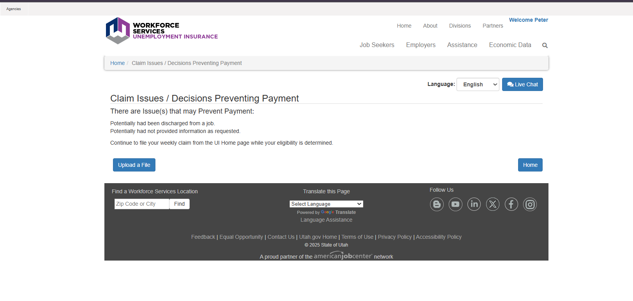

I have no idea what the issue is but it could be just that I marked that I might have been discharged even though I’m not even sure what that means. I know I worked harder than 90% of the teacher in that school district and students repeatedly came to me asking for me to be their home teacher, telling me about how awful it is to be in these schools, that have absolutely given up teaching, with teachers that regularly call the kids unteachable and honestly are the worst teachers I’ve ever seen, with absolutely no credentials or credential from fake universities. The two biggest degrees I’ve seen in these classrooms are from Utah Vally College and Pheonix University. These teachers can’t spell words like “science” and don’t know what “pedagogy” means. These are teachers who don’t know the definition of pedagogy. Obv this isn’t all of them, but it seems like the statistics are true… the absolute lowest scoring people who do actually take real tests like the GRE the people who go into education score the lowest, but these people aren’t just dumb they are so lazy. I know I never finished my phd at Berkelely but I do have an MA and an MS from Columbia and Berkeley. I know I have let our family down by going into publishing poetry and fiction instead of becoming a lawyer, and now am here begging for your help. But could you draft a letter that speaks the language of the unemployment office that gets them to make a decision—either give me the money or tell me what you want, but this continual insistence I keep filling weekly claims without receiving any result is driving me crazy.

ANSWER

Utah Department of Workforce Services
Unemployment Insurance Division
P.O. Box 45277
Salt Lake City, UT 84145-0277

Re: Peter Golub – SSN: 528-91-2127
Claim Effective Date: 05/18/2025
Request for Immediate Resolution of Payment Hold
Date: June 2, 2025

Dear Claims Administrator:

I am writing regarding the unexplained hold on Mr. Golub’s unemployment insurance benefits. Mr. Golub has been approved for benefits totaling $6,097.00 ($469.00 weekly for 13 weeks) but has received no payments despite filing all required weekly claims and job search documentation for the past two weeks.
The online system indicates an issue preventing payment, citing “discharged” and “not provide information” as concerns. I am writing to address these issues directly and request immediate release of the benefits owed to Mr. Golub.
First, regarding the discharge issue: Mr. Golub was NOT discharged for misconduct. His separation from Granite School District was the culmination of philosophical differences regarding educational methods and his advocacy for educational reform, including the integration of AI tutoring systems to address the district’s documented literacy crisis. While the district may characterize the separation differently, there was no misconduct, no violation of law or policy, and certainly no behavior that would disqualify him from unemployment benefits under Utah law.
The incident cited by the district—students conducting a brief dance activity after completing a Spanish test—was a classroom management decision made in the moment and hardly constitutes dischargeable misconduct. The students wanted to dance, and Mr. Golub let them.
The more serious allegation of using the f-word is also not reason for dismissing as Mr. Golub had used it in reference to himself not a student. This was regrettable but seeing as how long-term teachers regularly yell at students and use far more offensive language toward students, this is not the type of offense that would warrant a discharge.
Indeed, Mr. Golub himself was the target of false attacks by both administrators and faculty, all of which were proven baseless and motivated by personal bias, not Mr. Golub’s misconduct. Unfortunately, Mr. Golub no longer has access to his Granite School email or profile, but it should be noted that multiple students wrote to the district with letters of praise, citing Mr. Golub’s unprecedented attention to their education and, perhaps more importantly in this context, respect for students who are regularly referred to by other faculty as “unteachable” and “lost.”

Second, regarding information not provided:

Mr. Golub has submitted all requested documentation through your online portal. If additional information is required, your office has failed to specify what is needed. This lack of communication while continuing to require weekly filings without payment is unacceptable and potentially violates Utah’s unemployment insurance regulations requiring timely determinations.

Therefore, I request the following immediate actions:

- Release all pending benefit payments immediately, as no valid reason for withholding benefits has been established.
- If benefits cannot be released immediately, provide within 48 hours a detailed written explanation of:
  - Exactly what information or documentation is required
  - The specific statutory or regulatory basis for withholding benefits
  - A clear timeline for resolution
  - The appeals process if benefits are denied
- Confirm receipt of this correspondence and provide a direct contact for resolution of this matter.

Mr. Golub has met all eligibility requirements: he lost his job through no fault of his own, he is able and available for work, and he is actively seeking employment (exceeding the four weekly applications required). He has two advanced degrees from Columbia and Berkeley and devoted two years to attempting to improve educational outcomes for underserved students in your state. He deserves the benefits he has earned.
The Department's continued delay in payment while requiring ongoing compliance with filing requirements appears arbitrary and is causing significant financial hardship. Utah law requires prompt payment of benefits to eligible claimants. Each day of delay compounds the harm to Mr. Golub.
I trust this matter will receive your immediate attention. Should you require any additional documentation or clarification, please contact me immediately at 509-654-6138, respond to this correspondence, or contact Mr. Golub at 801-618-7609. We are prepared to provide any reasonable documentation to expedite this process.
However, absent a legitimate basis for withholding benefits - which has not been provided despite two weeks of delay - we expect immediate release of all benefits owed.

Respectfully submitted,
John Benefiel
P28970
1818 Westlake Ave N.
Suite 228
Seattle, WA 98109
cc: Peter Golub

I’d like you to write a 1st-person follow-up letter to the one already sent (Letter to Utah Department of Workforce Services). In this document, we will provide first person answers to specific questions the Utah Department of Workforce Services might have about: nature of the separation; circumstances; “misconduct” element; the issue of whether Golub quit or were fired; and any other issues they might raise.

Here is what I’d told him earlier, but there might be additional useful information. We want to use this to write a first-person letter. I’ve provided some examples of how he might answer that can be used in our draft. Thx!

- Utah unemployment law distinguishes between being “discharged” (fired/let go) and “quitting” (voluntarily resigning).
- The reason for separation is critical: If you were discharged for “misconduct,” you may be disqualified. If you quit, you must show “good cause” related to the job (not just philosophical differences) to qualify.
- The state is looking for facts, not lengthy stories or editorializing. Keep your answer focused, factual, and professional.

Here are some possible ways to frame the explanations for the four above points

1. Clarify the Nature of Separation

Based on your account, it appears that you left during a meeting after being accused of inappropriate conduct, but you were not formally fired on the spot. This is sometimes called a “constructive discharge,” or “quit in lieu of discharge.” In Utah, this can be a gray area.

How to explain:

“I was called into a meeting with administrators regarding concerns about my teaching style and language. During the meeting, I was accused of inappropriate conduct, which I disputed. I was upset by the accusations and, feeling that the situation had become untenable and that I was being unfairly treated, I left the meeting and did not return to work. I was not formally terminated at that moment, but I no longer had access to my accounts and was not contacted to return.”

2. Describe the Circumstances Factually
Focus on the facts, not your opinions about the school or colleagues.
How to explain:
“There were disagreements between myself and the administration regarding classroom management and communication style. I acknowledge that I used inappropriate language on two occasions, which I regret and for which I apologized. However, I felt that the administration’s response was disproportionate and that I was being singled out unfairly. The final incident involved an accusation that was not substantiated, and after that meeting, I chose to leave.”
3. Address the “Misconduct” Element
Utah will want to know if you were let go for “misconduct.” Misconduct is generally defined as a willful or deliberate violation of the employer’s rules or standards.

How to explain:
“While I did use inappropriate language, it was not directed at students but was a self-referential comment made in a moment of frustration. I apologized for this. I did not violate any other school policies intentionally, and I did not engage in any illegal or dangerous behavior. The other accusations were not substantiated by any evidence.”
4. If Asked: “Did You Quit or Were You Fired?”
If you left during a meeting and were not formally terminated, you can say:
“I left the meeting because I felt the accusations were unfair and the work environment had become hostile. I was not told I was fired, but I was not contacted to return, and my access was revoked.”

Sample Answer for the Interview
“My separation from my last employer was due to a series of disagreements with the administration about classroom management and communication style. I was called into meetings regarding concerns about my language and teaching methods. I acknowledge that I used inappropriate language on two occasions, which I regret and for which I apologized. During the final meeting, I was accused of inappropriate conduct that was not substantiated. Feeling that I was being treated unfairly and that the work environment had become hostile, I left the meeting and did not return. I was not formally terminated, but my access to school systems was revoked and I was not contacted to return.”

Additional Tips
- Avoid blaming others or venting. Keep your tone neutral and professional.
- Be honest, but concise. Focus on what you did, what you regret, and what steps you took to address concerns.
- If asked if you would return: “Given the circumstances, I do not believe it would be productive for me to return to that environment.”

# Follow-up Letter to Utah Department of Workforce Services

**[Date: June 13, 2025]**

Utah Department of Workforce Services
Unemployment Insurance Division
P.O. Box 45277
Salt Lake City, UT 84145-0277

**Re: Peter Golub - SSN: XXX-XX-2127
Claim Effective Date: 05/18/2025
Response to Request for Additional Information**

Dear Claims Examiner:

I am writing to provide clarification regarding my separation from Granite School District, as requested. My attorney submitted a letter on my behalf on June 2, 2025, and I understand you may need additional information directly from me to process my unemployment claim.

**Nature of Separation**

I was called into a meeting with administrators on May 5, 2025, regarding concerns about my teaching methods. During this meeting, I was accused of inappropriate conduct, which I disputed. Feeling that the situation had become untenable and that I was being treated unfairly, I left the meeting and did not return to work. I was not formally terminated at that moment, but my district email access was immediately revoked and I was not contacted to return. While I left the meeting of my own accord, I believe this constitutes a constructive discharge given the hostile circumstances.

**Circumstances of Separation**

There were ongoing disagreements between myself and the administration regarding classroom management and teaching methodology. I acknowledge that I used inappropriate language on two documented occasions - specifically, saying "I'm fucking German" in class. I regret this lapse in judgment and apologized for it. However, I felt the administration's response was disproportionate. The final incident on May 5 involved an accusation of drug use with students, which was investigated by law enforcement including a K-9 unit and found to be completely unsubstantiated.

**Regarding Misconduct**

While I did use inappropriate language, it was a self-referential comment made in frustration, not directed at students. I did not violate any other school policies intentionally, and I did not engage in any illegal or dangerous behavior. The serious accusation made on May 5 was investigated and no evidence was found. I had previously gone through one district review for the language issue, was cleared to continue teaching, and then was subjected to a second review for an incident that had occurred weeks earlier.

**Did I Quit or Was I Fired?**

I left the May 5 meeting because the accusations were demonstrably false and the work environment had become hostile. I was not explicitly told I was fired, but I was immediately locked out of all district systems and was not contacted to return. Given these circumstances, I believe this was effectively a termination, though I acknowledge I physically left the meeting.

**Additional Context**

Throughout my two years with the district, I maintained a professional demeanor, wearing a suit and tie daily and focusing on improving educational outcomes for underserved students. While I advocated for educational reforms including the use of AI tutoring systems, this advocacy was always conducted professionally and with students' best interests in mind. My separation was not due to performance issues but rather philosophical differences about educational methods and an escalating pattern of what I perceived as retaliation for my advocacy efforts.

I am ready and willing to work, actively seeking employment, and believe I meet all eligibility requirements for unemployment benefits. I separated from my position due to circumstances that made continued employment untenable, not due to any disqualifying misconduct.

Thank you for your consideration. Please contact me if you need any additional information.

Sincerely,

Peter Golub
3921 South 2000 East
Holladay, UT 84124
[Phone number]
[Email address]

**Attachments:** None

